**LAB # 10**

**Task # 01: Write a program for exam department which provide abstract class and method of Exam type which contains general methods related to exams and can be used by different department for conducting exams.**

**Solution:**

**public static void main(String[] args) {**

System.out.println("\n\t-------- BSE --------\n");

Exam_dep e1 = new BSE();

e1.seating();

e1.startExamDate();

e1.endExamDate();

e1.courses();

System.out.println("\n\t-------- IT --------\n");

Exam_dep e2 = new IT();

e2.seating();

e2.startExamDate();

e2.endExamDate();

e2.courses();

}

**public abstract class Exam_dep {**

public void seating() { System.out.println("SEATING PLAN IN BAHRIA -----"); }

abstract public void startExamDate();

abstract public void endExamDate();

abstract public void courses();

}

**public class BSE extends Exam_dep {**

public void startExamDate(){ System.out.println("BSE EXAMS START FROM 22-JUNE--"); }

public void endExamDate() { System.out.println("BSE EXAMS END AT 28-JUNE--"); }

public void courses(){ System.out.println("BSE HAVE 7 COURSES--"); }

}

**public class IT extends Exam_dep {**

public void startExamDate(){ System.out.println("IT EXAMS START FROM 23-JUNE--"); }

public void endExamDate() { System.out.println("IT EXAMS END AT 30-JUNE--");}

public void courses(){System.out.println("IT HAVE 8 COURSES--"); }

}

**Output:**

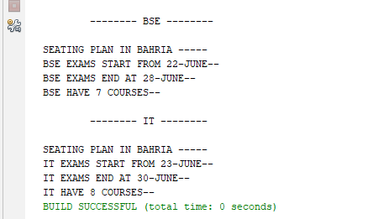

1. **Task # 02: You have to implement the UML diagram given below.Also Design and implement a subclass “Equilateral Triangle” having a double variable side denoting the three sides of the equilateral triangle [Note that since all the 3 sides are equal, the constructor will have only one parameter]. The area and perimeter of the equilateral triangle are given as follows:**

**Area = ¼**(*side*)2**

Perimeter = 3\**side*

Provide accessor methods for the sides. Test your class using the TestShapes and DownCastingShapes classes.

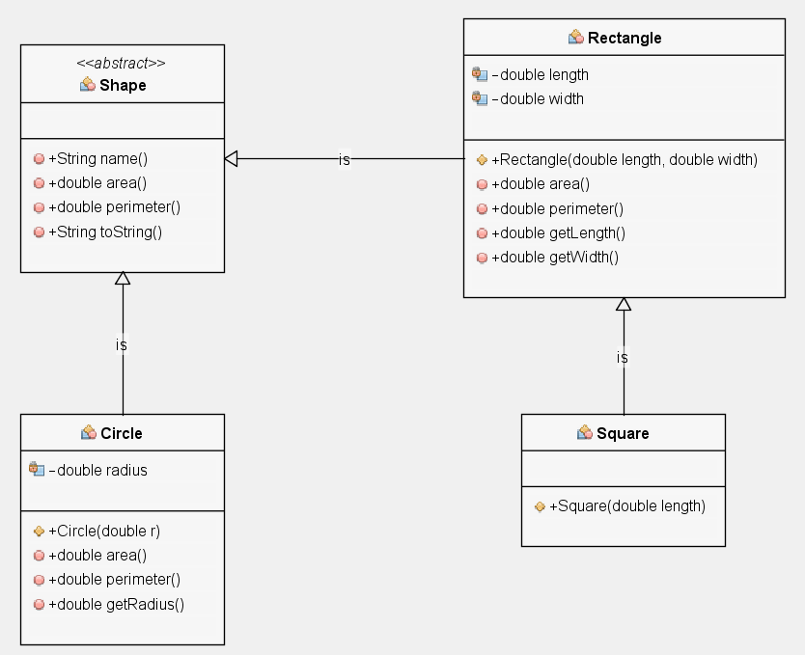

**Solution:**

**public static void main(String[] args) {**

// TODO code application logic here

Shape s=new Circle(3);

Shape s1=new Rectangle(3.0,2.0);

Shape s2=new EquilateralTriangle(3.0);

Rectangle s3=new Square(3);

System.out.println(s);

System.out.println(s1);

System.out.println(s2);

System.out.println(s3);

System.out.println("\n\t------DOWNCASTING EXAMPLE");

Circle c=(Circle)s;

System.out.println(c);

}

**public abstract class Shape** {

public String name() {

return " ";

}

public abstract double area();

public abstract double perimeter();

public String toString() {

return "\n" + name() + "\n Area=" + area() + "\nPerimeter=" + perimeter() + "\n-----------------------------------";

}

}

**public class Circle extends Shape{**

private double radius;

public String name(){

return "Circle";

}

public Circle(double r){

radius = r;

}

public double area(){

return Math.PI * (radius * radius);

}

public double perimeter(){

return 2.0 * Math.PI * radius;

}

public double getRadius(){

return radius;

}

}

**public class EquilateralTriangle extends Shape{**

private double side;

private double area;

public String name(){

return "EquilateralTriangle";

}

public EquilateralTriangle(double side) {

this.side = side;

}

public double getSide() {

return side; }

public double area(){

area= Math.sqrt(3)*0.5*3 *side*side;

return area; }

public double perimeter(){

return 3 * side;

} }

**public class Square extends Rectangle {**

public String name(){ return "Square"; }

public Square(double length){

super(length, length);

}}

**Output:**

